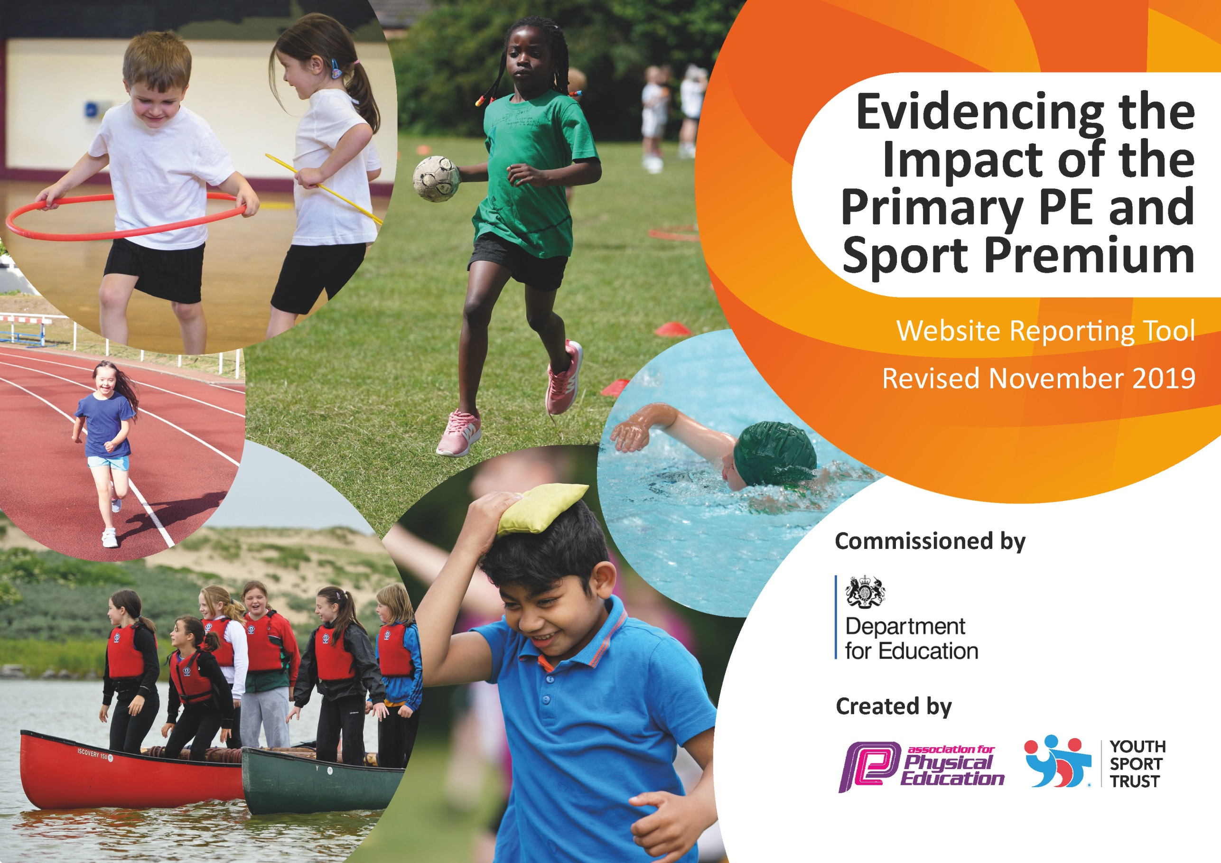
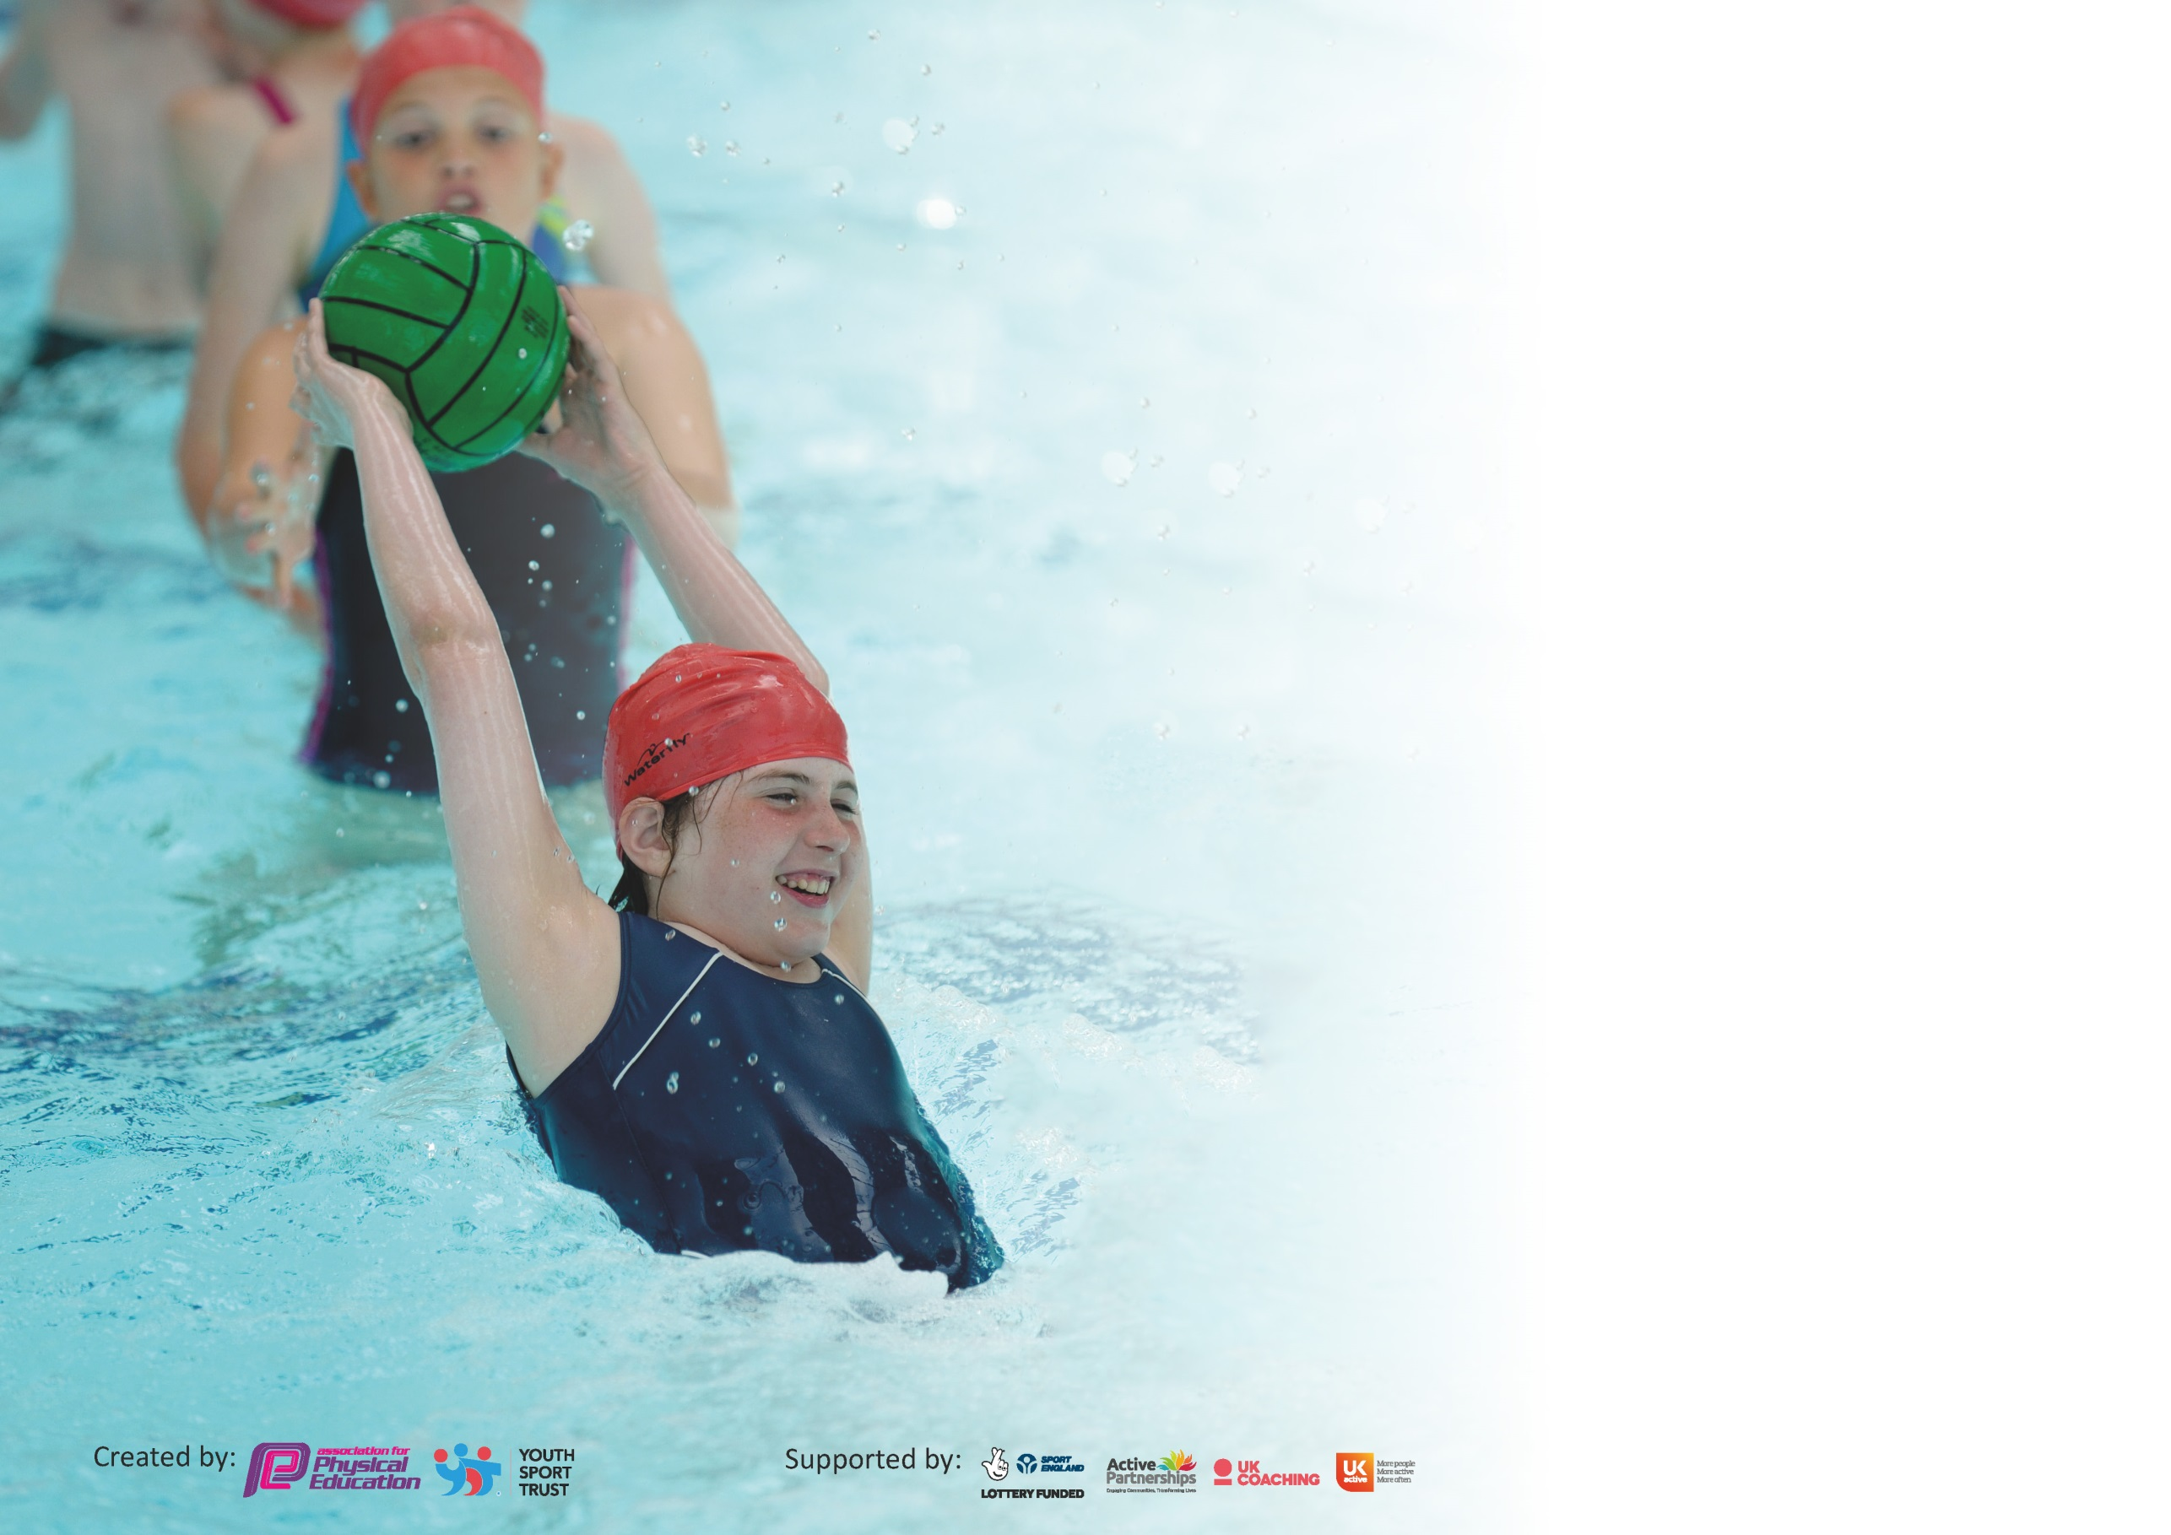

It is important that your grant is used effectively and based on school need. The Education Inspection Framework (Ofsted 2019 p64) makes clear there will be a focus on ‘whether leaders and those responsible for governors all understand their respective roles and perform these in a way that enhances the effectiveness of the school’.

Under the Quality of Education criteria (p41) inspectors consider the extent to which schools can articulate their curriculum (INTENT), construct their curriculum (IMPLEMENTATION) and demonstrate the outcomes which result (IMPACT).

To assist schools with common transferable language this template has been developed to utilise the same three headings which should make your plans easily transferable between working documents.

Schools must use the funding to make additional and sustainable improvements to the quality of Physical Education, School Sport and Physical Activity (PESSPA) they offer. This means that you should
use the Primary PE and Sport Premium to:

- Develop or add to the PESSPA activities that your school already offer
- Build capacity and capability within the school to ensure that improvements made now will benefit pupils joining the school in future years

Please visit gov.uk for the revised DfE guidance including the 5 key indicators across which schools should demonstrate an improvement. This document will help you to review your provision and to report your spend. DfE encourages schools to use this template as an effective way of meeting the reporting requirements of the Primary PE and Sport Premium.

We recommend you start by reflecting on the impact of current provision and reviewing the previous spend.

Schools are required to publish details of how they spend this funding as well as on the impact it has on pupils’ PE and sport participation and attainment by the end of the summer term or by 31st July 2020 at the latest.

We recommend regularly updating the table and publishing it on your website throughout the year. This evidences your ongoing self-evaluation of how you are using the funding to secure maximum, sustainable impact. Final copy must be posted on your website by the end of the academic year and no later than the 31st July 2020. To see an example of how to complete the table please click HERE.

Support for review and reflection - considering the 5 key indicators from DfE, what development needs are a priority for your setting and your pupils now and why? Use the space below to reflect on previous spend and key achievements and areas for development.

Key achievements to date until July 2019: | Areas for further improvement and baseline evidence of need:
- We offer all children a broad and balanced PE curriculum.  - PE lessons are of high quality and children are making fantastic progress.  - We offer a variety of different extra-curricular clubs and competitions that focus on different groups of children e.g. competition groups, inclusion groups e.g. least active girls, leadership groups etc.  - Children are becoming more active before, during and after school. | - The ‘Healthy Body and Minds’ project was introduced by the PE department last year to increase children’s understanding of health and raise participation in physical activity. This has enabled our children to become healthier, happier and more active. This will be further developed this year.  - To use a range of strategies to improve our swimming results. The process for this began last year and has started to be implemented this current year. Our Y4 cohorts take part in swimming, therefore it will take 2 years from implementing these strategies to see any significant results in the tables below (Y4 raw data however can be analysed).

Meeting national curriculum requirements for swimming and water safety.
What percentage of your current Year 6 cohort swim competently, confidently and proficiently over a distance of at least 25 metres?  N.B. Even though your pupils may swim in another year please report on their attainment on leaving  primary school at the end of the summer term 2020. | 69.5%
What percentage of your current Year 6 cohort use a range of strokes effectively [for example, front crawl, backstroke and breaststroke]? | 57.4%
What percentage of your current Year 6 cohort perform safe self-rescue in different water-based situations? | 98.4%
Schools can choose to use the Primary PE and Sport Premium to provide additional provision for swimming but this must be for activity over and above the national curriculum requirements. Have you used it in this way? | Yes

Action Plan and Budget Tracking
Capture your intended annual spend against the 5 key indicators. Clarify the success criteria and evidence of impact that you intend to measure to evaluate for pupils today and for the future.

**Please note that in the ‘funding allocated’ column, the total amount has been given to indicate the large proportion of money that goes into PESSPA. Some of these figures are repeated due to them being used across different key indicators. The 2 specialist PE teachers are employed by the school via the school budget, therefore any costings are in addition to PPA cover e.g. extra-PE lessons, staff CPD, extra-curricular clubs/competitions etc.

Academic Year: 2019/20 | Total fund allocated: £ | Date Updated:
Key indicator 1: The engagement of all pupils in regular physical activity – Chief Medical Officer guidelines recommend that primary school pupils undertake at least 30 minutes of physical activity a day in school |  |  |  | Percentage of total allocation:
 |  |  |  | %
Intent | Implementation |  | Impact
Your school focus should be clear what you want the pupils to know and be able to do and about  what they need to learn and to  consolidate through practice: | Make sure your actions to achieve are linked to your intentions: | Funding allocated: | Evidence of impact: what do pupils now know and what can they now do? What has changed?: | Sustainability and suggested next steps:
1. Develop the safe and effective use of Cedarwood (our outdoor active area) at breaks, lunchtimes, in lessons and after school, to encourage physical activity. | Continued staff training and safety procedures to enable children to access all areas of Cedarwood, including a staff rota at lunchtimes. Staff to plan incorporating Cedarwood into their lessons. | £1000 for Cedarwood upkeep | Children are accessing Cedarwood throughout the school day i.e. breaks, lunchtimes, lesson time and after school. This is increasing the amount of physical activity our children are doing. | To continue to use Cedarwood in a variety of different settings. For staff to share ideas of what they have done in lessons. To maintain staff training and risk assessments as well as upkeep.
2. Promote physical activity at break and lunchtimes through structured activities | Sports Coaches (from Stocksbridge Leisure Centre), play leaders and a PE Apprentice are employed to lead structured sessions at lunchtimes e.g. football, skipping, encouraging use of Cedarwood etc, targeting the least active. | Sports Coach £3020  PE Apprentice £8436  Play Leaders £9459 | Behaviour and physical activity has improved at lunchtimes due to these activities, especially for the older boys. Specific children with low levels of physical activity were ‘targeted’ to join in with set activities. | The sports coach and two specialist PE teachers liaise with the play leaders to give them activity ideas to use e.g. skipping workshops.  The PE apprentice is trained by our 2 specialist PE teachers.
3. Promote physical activity through resources and via Y6 sports leaders | Provide resources at lunchtimes e.g. team building crates, basketballs, footballs, skipping ropes.  Create a cohort of Y6 sports leaders. Train them up to lead set activities using the equipment provided with Y3 and 4 children at lunchtimes, targeting the least active. | Replacing damaged / new equipment £200. | Resources are being used by children at lunchtimes. This is facilitated through Play leaders and Y6 Sports leaders. Specific children with low levels of physical activity were ‘targeted’ to join in with set activities. | The PE specialist teachers and Links partnership work with the Y6 sports leaders during the year to give them ideas for sessions. Resources are looked after in our Cedarwood Store PE play store.
4. Promoting physical activity through ‘Active Travel’ | Promote active travel to school during the year. At certain times during the year e.g. healthy week, take part in the Active Travel initiative (sticker chart and rewards).  Bikeability is also run each year to teach the older children how to ride their bikes safely. |  | Awareness of active travel has been raised and active travel ‘peaks’ during these initiatives. More children are choosing to come to school by walking, scooter, bike etc. Children who live further out are encouraged to get dropped off close to the school and then ‘travel’ up themselves | To continue to promote Active Travel during the year.  To continue to provide Bikeability training for our children.
5. Promoting regular physical activity through extra-curricular activities. Please see ‘Key indicator 4’ section 2.

6. Promoting physical activity in lessons (Maths, English etc) through the Healthy Body and Minds Project. Please see ‘Key indicator 3’ section 4.
7. Promoting physical activity through the Scrapshed Scheme | Scrapshed provides children with physical items for active play. Staff training and resources are provided. This is used at lunch times via the play leaders, in lessons and after school. | £2000 | This scheme has developed children’s creativity, teamwork and communication skills. It has allowed those children who wouldn’t choose to play with sporting equipment at lunchtime to be more active and engaged. It has been successfully used in class to promote teamwork and cooperation. | The resources are replenished three times a year. All play leaders and staff are trained in the concept of Scrapshed. Staff are even bringing in items that can be used, which promotes the concept of ‘upcycling’ e.g. old computer keyboards!
Key indicator 2: The profile of PESSPA being raised across the school as a tool for whole school improvement |  |  |  | Percentage of total allocation:
 |  |  |  | %
Intent | Implementation |  | Impact
Your school focus should be clear what you want the pupils to know and be able to do and about  what they need to learn and to  consolidate through practice: | Make sure your actions to achieve are linked to your intentions: | Funding allocated: | Evidence of impact: what do pupils now know and what can they now do? What has changed?: | Sustainability and suggested next steps:
1. Specialist PE teachers employed to raise the standards of PESSPA across the school. | Raise the quality of teaching and learning in P.E.  Develop a broad and balanced curriculum.  Increase participation in PE and sport, with a focus on engaging the least active.  Develop a variety of activities, not just ‘traditional’ ones. | 2 Specialist PE teachers** | Children have stated that they benefit much more from their PE lessons now because:  They are more active in lessons  They take part in a variety of sports  They are learning different concepts e.g. muscle names  They are entering more competitions and there are more extra-curricular clubs available | Continue to provide high quality PE lessons for all children in school.  Support staff who are teaching additional PE lessons.
2. Dedicated timetabled events:  Healthy week  Sports day  SMART days e.g. Science | Children to take part in a variety of different activities e.g. Discovery Kitchen (food making/tasting), rowing, fencing, dance, smoothie bike.  Cross curricular links are made via classroom/physical tasks e.g. healthy eating, diet, heart rate, nutrition and this is enforced in PE lessons too. | Use of coaches and equipment for healthy week is part of our Links membership fee: £1800. Additional costs e.g. £200 for the Healthy Kitchen are made. | Children take part in a variety of different activities. Children thoroughly enjoy these events, which motivates them to be more physically active. Some children even go on to do those activities out of school via our school-club links e.g. karate, tennis.  Children develop their understanding of health and wellbeing. | Continue to run these timetabled events. To try out different activities with the children – possibly trampolining at the leisure centre? Use our new SSCO to teach some dance sessions?
3. Targeted programmes e.g. Mini Mermaids Programme and Active Girls Club (Mrs Foster) – To increase awareness of health and physical activity in our least active/vulnerable girls in the school | Eight-week programme which is designed to boost confidence and self-esteem for girls. They take part in sessions which encourages mindfulness in addition to enjoying fun physical activities.  Other girls that have been identified as ‘least active’, those who present social/emotional concerns or those who need a confidence boost are targeted for Mrs Fosters Active Girls Club. | £195 – Mini mermaids  Mrs Foster – Specialist PE teacher** | Teachers have noticed an increase in confidence in these girls and they have also been more enthusiastic in their PE lessons. The Sheffield Telegraph has previously been into school to write an article about the success of the programme. This is also on the school website. | Continue to support these girls to encourage them to stay physically active.  Create new cohorts.
4. Utilise local facilities and external agencies | Liaise with the PE department at the High school to allow a successful transition process e.g. Y10 sports leaders assist in our local cluster competitions in their sports hall  External coaches into school e.g. Y3/4 football training, healthy week, taster days e.g. karate | Links membership fee: £1800 | Children ‘get used to’ being at the High school, which aids for a smoother transition process.  Children get the opportunity to take part in clubs which staff wouldn’t be able to run e.g. on staff training night. | Continue to create more school-club links. We currently have:  Stoscksbridge Leisure centre  Stocksbridge Rugby Club  Stocksbridge Cricket Club  Nicola Priestly Academy of Dance  Stocksbridge Park Steels and Junior Foxes Football Club  Pheonix Gymnastics Club  Kickboxing/karate – Richard Taylor Reactive Fitness  Stocksbridge Tennis Club  City of Sheffield Running Club –Team Russell – Jamie Russell  Stocksbridge Pentaqua Swimming Club  Judo – Gareth Howell  Coaches through Links membership e.g. dance
5. Use of school newsletter and school website (PE blog) to promote PESSPA in school | Each competition or sporting event recorded on the school website via the PE blog and put on the school newsletter.  PE star of the week for Mrs Foster and Mr Tee. | 2 Specialist PE teachers** | Improved communication with parents and sharing of success of school events/competitions encourages parents to get more involved in encouraging their children to take part in physical activity. | Continue to provide good communication via the school website and newsletter.

Key indicator 3: Increased confidence, knowledge and skills of all staff in teaching PE and sport |  |  |  | Percentage of total allocation:
 |  |  |  | %
Intent | Implementation |  | Impact
Your school focus should be clear | Make sure your actions to | Funding | Evidence of impact: what do | Sustainability and suggested
what you want the pupils to know | achieve are linked to your | allocated: | pupils now know and what | next steps:
and be able to do and about | intentions: |  | can they now do? What has
what they need to learn and to |  |  | changed?:
consolidate through practice:
1. To provide staff CPD to improve the confidence of staff and quality of physical education being delivered to our children (in addition to their high quality PE lessons with specialist PE teachers).  Staff are encouraged to assist in extra-curricular clubs to improve knowledge and confidence  To allow PE staff to have training where necessary. | The 2 specialist PE teachers previously ran whole school CPD for all staff on a rota basis. Confidence has now increased and staff can also teach PE in their own time and assistance is provided by the PE team if necessary e.g. Y6 rounders lessons. Any new members of staff are supported with individual training where necessary.  PE staff are encouraged to attend CPD e.g. Sports Conference, coaching in sports the feel less confident with e.g. tennis | 2 Specialist PE teachers** | After the original CPD, teachers feel more confident at teaching PE. The idea of the specialist teachers is to facilitate good practice, rather than de-skill staff. Some staff have got involved in after school clubs e.g. MC football training / AP – gymnastics. | To continue CPD of new staff. To raise standards of teaching PE even further. To increase staff confidence in more complex activities e.g. gymnastics, OAA etc.
2. To continue to develop the PE network for Locality G (for PE lead teachers). | Develop the PE network to improve the quality of PE teaching across locality G (SJS set this PE network up originally and have led on this since then). This has included lesson observations, assessment practices, promoting good practice, developing structured ideas etc.  This year has specifically included training for classroom teachers in locality G that are NQT/RQT and low in confidence at Stoscksbridge Junior School. | 2 Specialist PE teachers** | PE leads feel much more confident in teaching PE lessons. More importantly, staff feel more attuned with assessment practices for use in their schools. This will therefore have a positive knock on effect on the quality of PE and sport in our locality. Staff also have ‘links’ to support each other during different processes e.g. assessment practices.  The staff who attended the most recent training (NQT/RQT and low in confidence) found the session extremely useful and went away to try new ideas. | To continue to PE network. To meet at the end of the year to discuss further steps on where to take the group next year.
3. To promote high quality PE through being a Centre of Excellence for PE. | SJS was given Centre of Excellence status by the Yorkshire Sport Foundation. This has made us a ‘hub’ for good practice in PE. We have provided CPD for a variety of schools in South Yorkshire to encourage good practice and promote PE and school sport.  Most recently, we are supporting a school in Doncaster who has a new PE lead in place. | 2 Specialist PE teachers** | The PE department at SJS has allowed schools to improve specific areas that they were struggling with e.g. assessment, timetabling, AFL etc. | To continue to promote good practice via the Centre of Excellence programme. To create more links with schools around South Yorkshire.
4. Healthy Body and Minds project – to increase physical activity in ‘structured teaching time’ e.g. Maths, English etc | The 'Healthy Body and Minds' project began last year in school and focuses on the importance of physical activity to improve children's health, attainment and concentration. Staff have attended a meeting which looked at this and are being encouraged to use 'Go Noodle' and other activities e.g. ‘mile a day’ to act as 'brain breaks' within their lessons. In addition, the Y6 sports leaders have been leading lunchtime sessions to encourage Y3/4 children to get active. Breakfast club is also situated next to the hall, so children can come and have a healthy breakfast if they missed it at home. | 2 Specialist PE teachers** | This was initially trialled by one of the members of staff and has proven to be extremely successful for those classes with regards to children's focus and quality of work produced. Each staff have got an ‘avatar’ for their class on ‘Go Noodle’ and are totalling up their minutes of activity during lesson times. A bank of other resources is being created for all staff to share on the school network e.g. team building tasks.  The Y6 sports leaders are thriving. | To collate the results of Go noodle. To get feedback from staff regarding the use of brain breaks in their lessons. To collate the bank of resources on the network for all staff to use when they wish in their lessons.
5. Providing a placement for Primary PE Specialist PGCE students | Working with Sarah Williams (Senior Lecturer from Sheffield Hallam) to provide placements for primary PE specialist trainees (PGCE). | 2 Specialist PE teachers** | These students come away from their placement feeling confident and competent at teaching PE. They gain valuable experience of PE and classroom teaching in an outstanding primary school. Many of which aspire to progress into a PE lead role in their first job. One of our PGCE students has been kept on as a classroom teacher! | To continue to provide placements for Sheffield Hallam University.
6. Utilising a PE apprentice within the school environment | We employ a PE apprentice every year through the Sheffield College. Their key responsibilities are:  - lunchtime activity sessions  - Assist sports leaders at lunchtime  - Organising equipment  - Organising letters/reply slips  - Team teaching in PE lessons  - Assisting with Y4 swimming sessions  - Provide a TA role for some children  - Assisting with after school activity clubs | PE Apprentice £8436 | The PE apprentice is a great addition to the staff team. They increase participation in PA during the school day e.g. lunchtime sessions, after school clubs. They assist in encouraging children to attend clubs and bring back reply slips. They gain skills and understanding of teaching by working alongside our specialist PE teachers. Many of our apprentices leave encouraged to want to be employed in a physically active role e.g. coaching, PE teacher etc. | To continue to liaise with Sheffield College to employ a PE apprentice for next year i.e. application form, interviews etc.
Key indicator 4: Broader experience of a range of sports and activities offered to all pupils |  |  |  | Percentage of total allocation:
 |  |  |  | %
Intent | Implementation |  | Impact
Your school focus should be clear | Make sure your actions to | Funding | Evidence of impact: what do | Sustainability and suggested
what you want the pupils to know | achieve are linked to your | allocated: | pupils now know and what | next steps:
and be able to do and about | intentions: |  | can they now do? What has
what they need to learn and to |  |  | changed?:
consolidate through practice:
1. Provide a broad and balanced curriculum in PE lessons | All children receive at least 2 hours of PE per week, which is timetabled with 2 specialist PE teachers (additional lessons are run by class teachers and through CPD sessions). These lessons provide high quality and challenging activities in a range of sports including: Basketball, Athletics, Gymnastics, Football , Dance, Netball, Rounders, Cricket, Tag rugby, Outdoor and adventurous activities / team building activities, Games and fitness e.g. dodgeball, obstacle course, skipping. | 2 Specialist PE Teachers**  Replacing damaged /new equipment £500.00 | Children are benefiting from a broad and balanced curriculum. AFL during lessons is showing all children are attaining expected progress, most are achieving good progress and many are achieving outstanding progress. High quality teaching is still occurring when there is bad weather and two classes are doing PE in the hall. | Adjusting the timetable to gain the best learning time e.g. Gymnastics lessons clash with the use of the hall around Christmas time.
2. Provide a range of extra-curricular opportunities | The PE Specialist Teachers lead a range of extra-curricular clubs at lunchtime and afterschool to increase levels of physical activity for all children in school.  Some clubs are focused on developing children’s skills in preparation for competitions e.g. gymnastics club, where as other clubs are focused purely on participation e.g. Y5 and Y6 football clubs are open to whole year groups, the Active Girls Club is targeted at the least active girls in Y4, 5 and 6. Specific children are identified for these clubs to encourage them increase their physical activity rates e.g. Y3 basketball club. Y6 sports leaders, play leaders, coaches and our PE apprentice will also target specific children at lunchtime to increase physical activity. External coaches are used when PE staff are not available on specific evenings e.g. staff meeting nights. | 2 Specialist PE Teachers** | There are high participation rates in all extra-curricular clubs. Karate and kickboxing was previously led at SJS to target children while PE staff were in staff meetings. This however did not produce great numbers, therefore we changed the club to lower school football and the response has been brilliant and the club is full.  The mini-mermaids club (see Key indicator 2, section 3) has been very successful at targeting specific girls in the school and is running again this year.  Our yearly ‘Inclusive sport’ event at the High School allows our more vulnerable children / SEN to become involved in sport at a level suitable for them e.g. seated volleyball, boccia. We ofted liaise with Marlcliffe to create our own Inclusive sport event, where children take part in circuit activities such as rowing. | To continue to monitor those children who are least active and find ways to encourage them to become involved in a variety of activities.  To assess the success of each club and alter accordingly, like we did with the karate club.
3. To allow all children in the school to access high quality swimming during their time at SJS  Nb. Funding is used for additional swimming needs and not the dedicated lessons. | Ensure Y4 children have access to swimming provision at Stocksbridge Leisure Centre for their weekly swimming lessons.  To organise extra swimming sessions for squad training.  Identify pupils that may need additional support to meet the minimum expectation and provide ‘top up’ lessons. | Leisure centre hire: £800 (this funding is also included in Key indicator 5, section 2). | Pupils know the dangers of water locally and nationally.  Non swimmers to have support in achieving 25m thus meeting the statutory requirements of the National Curriculum for PE.  Pupils know what to do if others get into difficulty in water. | To use a range of strategies to improve our swimming results (initial meetings have started regarding this area for improvement and progress is underway).  To target children who don’t achieve the swimming targets in Y5 and 6.
4. Develop children’s leadership opportunities to learn about different roles in PE. | All children get the opportunity to learn how to lead/coach/referee in a variety of sports during their PE lessons. They all know how to warm up correctly and can lead and name stretches e.g. gastrocnemious. We develop this further by using ‘sport education’ as a basis for our assessment lessons, where children get the chance to develop a number of different roles including:  - Captain  - Score keeper  - Warm up/skill drill leader  - Player of the match selector  - Referee  There are also leadership opportunities in Y6 as a sports leader and specific children are also asked to ‘support’ extra-curricular activities in a sporting role e.g. umpiring in rounders. | 2 Specialist PE Teachers** | All children have a basic knowledge and understanding of leadership through PE and are confident at leading, managing and officiating a variety of sports.  Children are encouraged to ‘manage’ games themselves and we give them strategies to prevent problems occurring within the games. This has massively improved children’s teamwork and cooperation skills. | To continue to allow children to partake in other roles besides the ‘performer’ in PE lessons and extra-curricular activities.

Key indicator 5: Increased participation in competitive sport |  |  |  | Percentage of total allocation:
 |  |  |  | %
Intent | Implementation |  | Impact
Your school focus should be clear | Make sure your actions to | Funding | Evidence of impact: what do | Sustainability and suggested
what you want the pupils to know | achieve are linked to your | allocated: | pupils now know and what | next steps:
and be able to do and about | intentions: |  | can they now do? What has
what they need to learn and to |  |  | changed?:
consolidate through practice:
1. To use intra-school competition in different contexts to allow ALL children opportunity to compete | Intra-school competitions occur throughout the year in PE lessons, sports days and in healthy week. In PE lessons, all children compete in modified games and activities to improve their knowledge of rules, develop teamwork and to promote competition. We have 4 houses that can be used in intra-school competition and form the basis for our sports day: Hunshelf, Ewden, Broomhead, Wharncliffe. | PE Specialist Teachers** | Children enjoy using the knowledge and skills that they have gained through each physical activity unit in order to implement it into competition at the end of the unit.  Children are learning key skills like teamwork, cooperation, leadership and understanding how to tackle problems by themselves. | To continue to use intra-school competition in a variety of contexts.
2. To take part in a variety of school competitions, including those for children with SEN. | Enter a variety of competitions, many of which have up to 4 rounds.  Round 1: Cluster competition  Round 2: Partnership competition  Round 3: City Finals  Round 4: South Yorkshire Finals.  Pay SFSS subscription fee.  Coach hire is required for some of these competitions – parents pay a subsidised rate.  Hire leisure centre for team training – athletics and swimming teams.  This year, we have entered more teams for competitions to increase numbers of children competiting e.g. Sportshall athletics, we entered 2 teams – 40 children competed! | Specialist PE Teachers**  Links membership fee: £1800  SFSS fee: £85  Coach/minibus hire: £800.00  Leisure centre hire: £800.00 | Children are having the opportunity to take part in a range of inter-school competitions during their school life. This is increasing children’s confidence and allowing them to experience different settings outside of school e.g. Ponds Forge, EIS etc. These competitions include:  - Sportshall athletics – Y4 and Y6 events  - Outdoor athletics - Y5 and Y6 teams  - Hotshots basketball - Y4 and Y5 teams  - Cross County (all years) – Saturday competitions  - Inclusive sport festival – all years (SEN/vulnerable)  - Cricket cluster – Y5  - Sheffield boys football league – Y5 and Y6 teams  - Sheffield girls football league – Y5/6 team  - Targeted Y6 boys football fixture with Oughtibridge  - Futsal – Y5 girls  - Gymnastics – all years – 4 teams  - Rounders Y5 and Y6 teams  - Rowing – Y6 – 2 teams  - Rugby – Y5/6  - Rugby festival – Y6 – 3 teams  - Swimming – all years – upper and lower school  - Partnership sports day Y3  - The fittest primary school competition | Continue to ensure all children get a chance to take part in sporting competition during their school life.  Increase the number of teams attending each event to allow more children to access competition.

Signed off by
Head Teacher: | Samantha Gaymond
Date: | 16/04/20
Subject Leader: | Tara Foster – PE Lead
Date: | 16/04/20
Governor: | Martin Booth
Date: | 16/04/20

