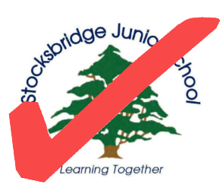

SJS Ready Badge

This is your first badge at Stocksbridge Junior School, it is your chance to show that you are SJS Ready!

How to earn this award:

Over the course of term 1a, these are the skills you need to cover.

In term 1b, we will test you to see what you can demonstrate in unstructured time

1. Can you demonstrate good manners in all lessons and in all areas of our school environment?
2. Create a ‘Who is Who?’ poster or information sheet to identify your key adults at SJS.
3. Show a greater independence when getting ready for PE, for example, can you tie your shoe laces?
4. Can you organise your daily routine?
5. Can you be a guide and give somebody a tour of our school? This could be as part of a team.
6. Learn at least five new skills. These should be agreed with your teacher and yourself.

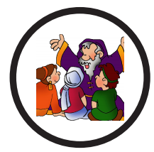

Storyteller Badge

How to earn your award:

- As a class, set or group take your storyteller rucksacks out into the outdoor space and learn a given story by heart.
The rucksack might include
  - A range of stories
  - Fancy dress costumes
  - Whiteboards
  - Pens
- Using an area of the outdoor environment as a stimulus, create in groups or individually a short story, which you can perform to an audience.
- Take part in a campfire, sing a range of campfire songs, and share a range of stories/poems.
- Select a range of natural materials with unusual aromas and use these to create a poem to be shared with an audience.

