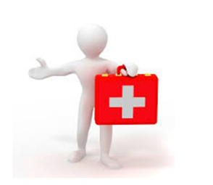
First Aider

Topic Link: A child’s war

How to earn your badge
You will need to take part in around two to three hours of training, which should be taught by an adult with relevant knowledge.
- Explain to your teacher or another adult about how to call 999.

- Learn how to deal with a casualty who is unconscious- Recovery position.

- Learn what to do when a casualty is unconscious and not breathing – CPR

- Learn how to deal with a casualty who is bleeding – Simple cuts/ hand bandage and head bandage.

- Learn what to do when someone is choking.

- Create a stretcher and move a casualty round a set course.

- Learn what to do when someone has a simple burn.

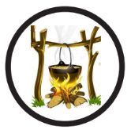
Outdoor Chef

How to earn your award:

- Learn how to light a fire in the fire pit with a suitable adult. Demonstrate this skill safely as part of a team under close supervision.
- As part of a group, demonstrate how to light the Kelly Kettle and make a hot drink.
- Devise a menu for 4 to 6 people including quantities.
- As a team, successfully cook the menu you have designed. Ensure you have cleaned up thoroughly afterwards.
- Aim to cook three of the following:
  - Bread twists
  - Baked potato in foil
  - Toasted marshmallows
  - Strawberry and oat crush biscuits
  - Chocolate bananas
  - Any food which is agreed with an appropriate adult

